|  |  |  |
| --- | --- | --- |
| **Firestick Project**  **Yarra Ranges Council** | | |
| Dixons Creek Primary School and Wurundjeri received the Australian Disaster Resilient  National School Award for their Firestick project, which saw students learn from Elders Uncle Dave Wandin  and Ralph Hume with Victor Steffensen about cultural fire and traditional fire practices. The environment features strongly as a base for growth of the Gannawarra brand.  The environment features strongly as a base for growth of the Gannawarra brand.  A community project driven by Yarra Ranges Council has led to recognition from Resilient Australia’s National School Award, celebrating a Wurundjeri-led firestick project involving students at Dixons Creek Primary School.  The State-supported project involved students learning about traditional fire practices, culture and the environment from Indigenous Wurundjeri Elders. Students learnt about traditional Aboriginal land management along with the symbolic and cultural aspects of fire. This innovative program helped local families affected by the 2009 bushfires to understand fire from a different perspective. Traditional knowledge of the environment helped the Indigenous community to burn country using the plants’ cycle to indicate small areas that were ready to burn, which is known as “cool burns”. |  |  |

**Find out more about Vic Councils  
viccouncils.asn.au**

**For more information on this project:**Tracey Varley  
Yarra Ranges Council  
E: t.varley@yarraranges.vic.gov.au  
P: (03) 9294 6226

This type of burning can help to heal country.

The project recognised the importance of involving and listening to children and young people in community projects, as they are the future leaders.

The book ‘*The Parent Trees are Talking*’ was produced during this project. The book is available across Eastern Regional Libraries in the Yarra Ranges and was given to schools in the surrounding impacted areas. The students delivered a live reading of the book on Reconciliation Day in 2018 and also presented project findings to a Federal Government disaster resilience committee.

The initiative has helped the broader community heal collectively and build resilience from the   
trauma of the 2009 Black Saturday fires. The project was led by Wurundjeri Elders with support from Yarra Ranges Council and the Department of Environment, Land, Water and Planning in Victoria.

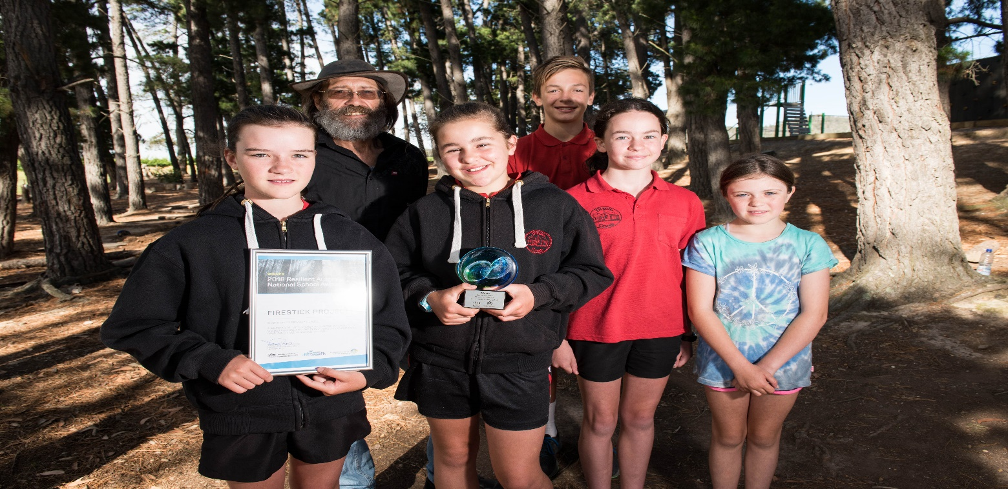

The book may be read and downloaded [online](https://firesticks.box.com/s/t3rbla9aki7mo7tfb1i6x2q64ylv9h2e). There is also a video available featuring Uncle David and the children’s drawings used in the storybook.

For more about this award-winning project, [visit the Firesticks website](https://www.firesticks.org.au/firesticks-recognised-in-national-resilience-award/) or [watch the video](https://www.youtube.com/watch?v=GAby63zE_aE).