|  |  |  |
| --- | --- | --- |
| **World-First  Library App  Yarra City Council**  Image of a mobile phone displaying the Yarra Libraries app | | |
| Yarra City Council recently introduced its world-first borrowing app that lets members scan their item and walk straight out – no queues, no checkouts, and no security alarm.  Members can also manage their account from the app; checking due dates, renewing their loans or cancelling reservations.  Unlike other library apps that still require members to scan their item again on a separate device, the Yarra Libraries app disables the security alarm as soon as the item is checked out.  Borrowing is now as easy as taking a photo with a smartphone or tablet, with the Yarra Libraries app. The app lets users self-checkout library items from one of Yarra Libraries’ five locations, as well as see everything they’ve borrowed at a glance, and book events and rooms. |  |  |

The Yarra Libraries app also includes a world-first integrated bookshelf that lets members see everything they’ve borrowed at a glance, whether physical or digital, without being redirected to external platforms.

This includes books and ebooks, magazines and audio.

The new app is just another way Yarra Libraries is evolving to help people discover learn, connect and collaborate through technology.

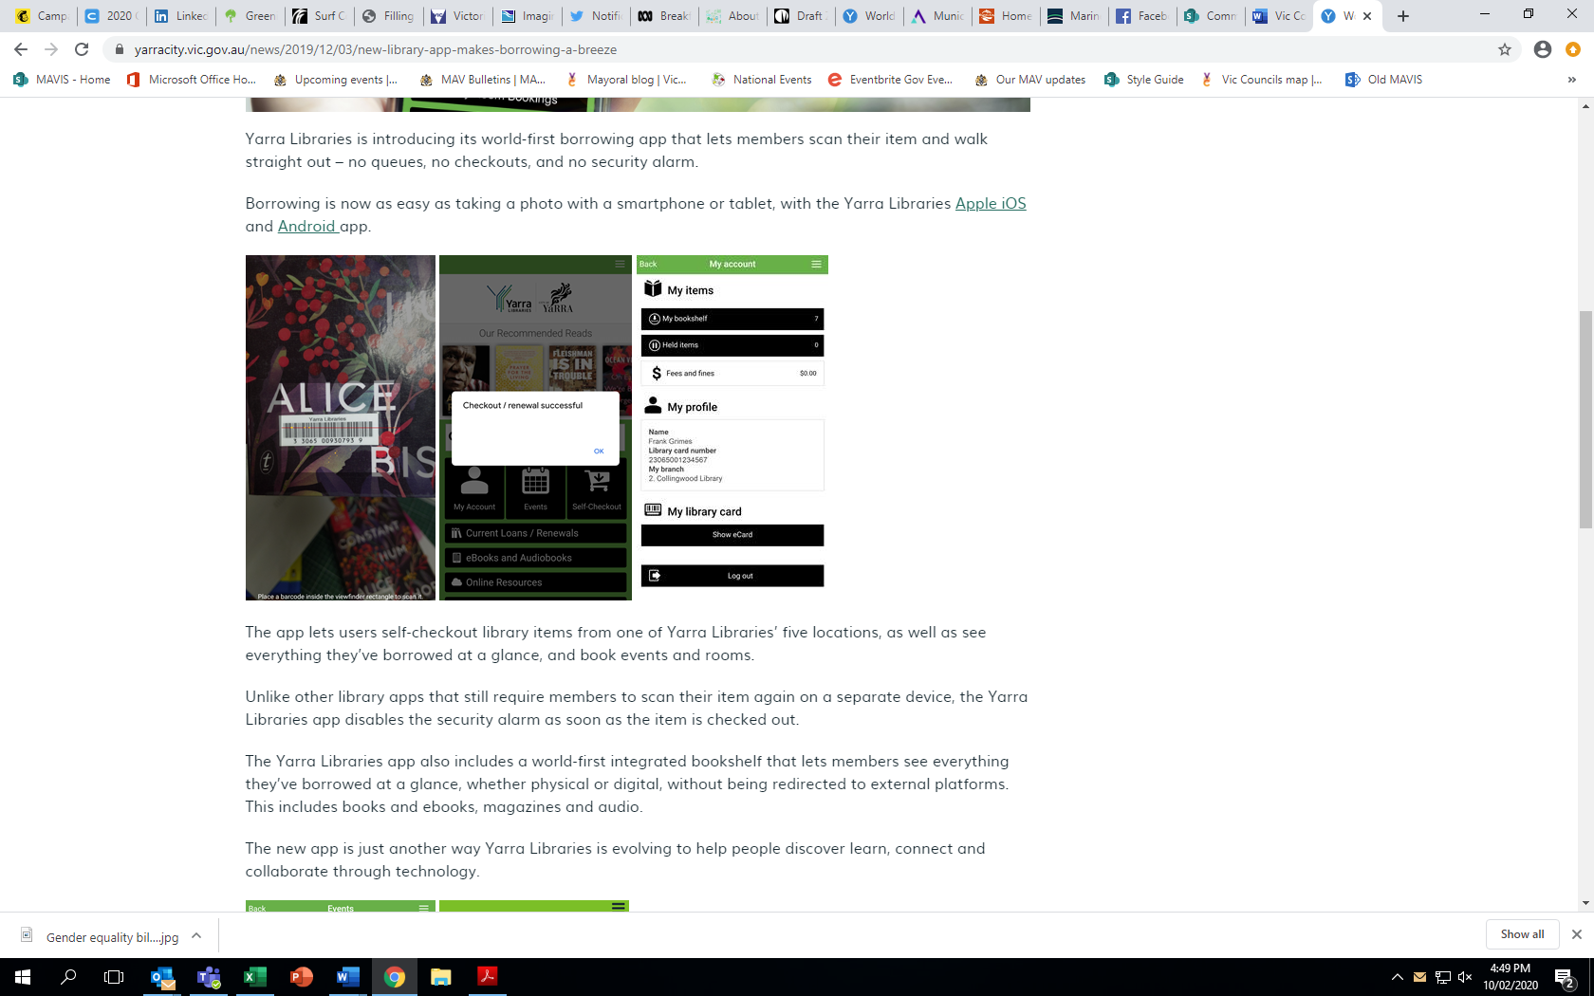

The app also allows members to reserve the highly sought-after study spaces at Bargoonga Nganjin, North Fitzroy Library, letting members see room availability in real-time.

Yarra Libraries partnered with library technology provider Communico to deliver the Yarra Libraries app.

To learn more visit the [Yarra City website](https://www.yarracity.vic.gov.au/news/2019/12/03/new-library-app-makes-borrowing-a-breeze).

**Find out more about Vic Councils  
viccouncils.asn.au**

**For more information on this project:**  
**Peter Huynh, Team Leader Information Technology**Yarra Libraries   
E: [peter.huynh@yarracity.vic.gov.au](mailto:peter.huynh@yarracity.vic.gov.au)  
T: 9205 5555

The app’s new events management feature allows members to browse and register for events using only their library card. Members can be added to a waitlist for sold-out events, and automatically be added when space is free.