|  |  |  |
| --- | --- | --- |
| **Data Gold in Ballarat City of Ballarat** | | |
| The work undertaken by the City of Ballarat creatively addresses the issues faced by historic cities  in prioritising urban conservation as the city grows and changes, including addressing practical challenges  such as short-term political cycles, siloed disciplines and minimal time to work in participatory ways with  locals to make sure we safeguard what they value.  The City of Ballarat was the first city to join a UNESCO international pilot program to implement the Historic Urban Landscapes (HUL) approach. The UN’s approach to managing change, known as the *Recommendation on Historic Urban Landscapes (HUL)* recognises challenges and complexities that many historic cities face.  This approach balances urban conservation and development with the complex and interrelated elements that make living and constantly changing communities distinct.  The work being undertaken in Ballarat addresses these challenges using digital technology, open data, comprehensive mapping and new understandings of the city. The approach taken by Ballarat brings together new comprehensive and engaging information with data that people want to use. |  |  |

Two initiatives were introduced as key 'open data' platforms for this pilot - the 'HULBallarat' and 'Visualising Ballarat' platforms. Both platforms were developed in conjunction with the Centre for eResearch and Digital Innovation (CeRDI) Federation University Australia.

*HULBallarat* is a collaborative community-focused platform bringing various types of information together, helping people engage with their city in new ways. *Visualising Ballarat* is a new ‘engine room’ that is building a knowledge base of the DNA of Ballarat and becoming an integral decision support tool for delivering the HUL approach.

Through this international pilot, Ballarat is capturing research methodology and sharing lessons with other cities in Australia and around the world.

**Find out more about Vic Councils  
viccouncils.asn.au**

**For more information on this project:**  
Susan Fayad  
Coordinator Heritage and Cultural Landscapes at the City of Ballarat  
E: meganfranzo@ballarat.vic.gov.au  
P: (03) 5320 5677 M: 0448 921 336

These initiatives were shortlisted in the 2019 MAV Technology Awards for Excellence for achievements in strategy and planning, and collaboration and partnership. The sites have brought together community activities, research and data from various sources and a new mapping interface and digital tools.

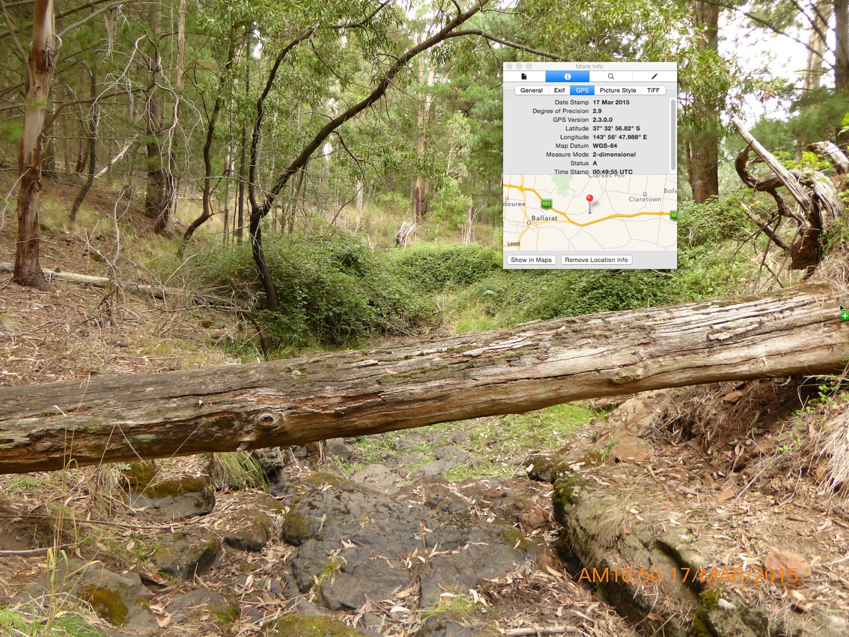

The project led to new digital tools such as ‘TimeCapsule Ballarat’ (developed by local ‘hackers’ via a ‘HUL’ award at GovHack Ballarat), ‘Songways Music Mapping’ – a City of Ballarat public art project and 3D virtual tours of the city with connections to research, projects and local community activities. Visit [HUL Ballarat](http://www.hulballarat.org.au/) and [MAV Technology](http://www.mavdigital.com/portfolio/awards-for-excellence/) to find out more about these initiatives.