|  |  |  |
| --- | --- | --- |
| **Large-Scale  Solar Development**  **Gannawarra Shire Council** | | |
| This award-winning large-scale solar farm is capable of generating power for 25,000 homes.  Gannawarra Shire Council has taken a strategic approach towards identifying future directions for the local economy around the platforms of nature-based tourism, renewable energy and innovative agriculture.  The environment features strongly as a base for growth of the Gannawarra brand.  The environment features strongly as a base for growth of the Gannawarra brand.  Gannawarra Shire is home to Australia’s largest integrated solar farm and battery storage facility. This groundbreaking solar farm was recognised in the [2018 Premier’s Sustainability Awards](http://www.sustainabilityawards.vic.gov.au/gannawarra-shire-council) as a winner in the category for the ‘Premier’s Regional Recognition Award’, which recognises local government contributions to sustainability initiatives in regional Victoria.  The Gannawarra Shire has abundant solar resources, a high-capacity terminal station and access to a transmission network - making it an ideal location for solar generation. Located west of Kerang, the Edify Energy/ Wirsol project hosts a 60-megawatt solar farm along with a 25-megawatt Tesla battery storage system. The large-scale solar farm is a first for the Gannawarra municipality and is one of seven large-scale solar projects that have been proposed for the Kerang area in Victoria. |  |  |

This initative will create new jobs and generate economic returns into the future for the local community, by employing between 80 and 200 construction jobs per project and an estimated 30 permanent jobs for ongoing positions.

It has increased Gannawarra Shire's investment profile and will attract new development to the area, with substantial rates revenue to be generated through the development of these projects.

The ability to supply goods and services to these large-scale solar projects will also allow other businesses to grow and flourish in the area.

The environment and renewable energy feature strongly as a base for growth of the Gannawarra brand.   
The Premier’s Sustainability Award recognises Council’s strategic commitment to sustainability initiatives and long-term plans for the current and future diversification of the Gannawarra economy.

**Find out more about Vic Councils  
viccouncils.asn.au**

**For more information on this project:**Communications Officer  
Gannawarra Shire Council  
E: media@gannawarra.vic.gov.au   
P: 0409 616 627

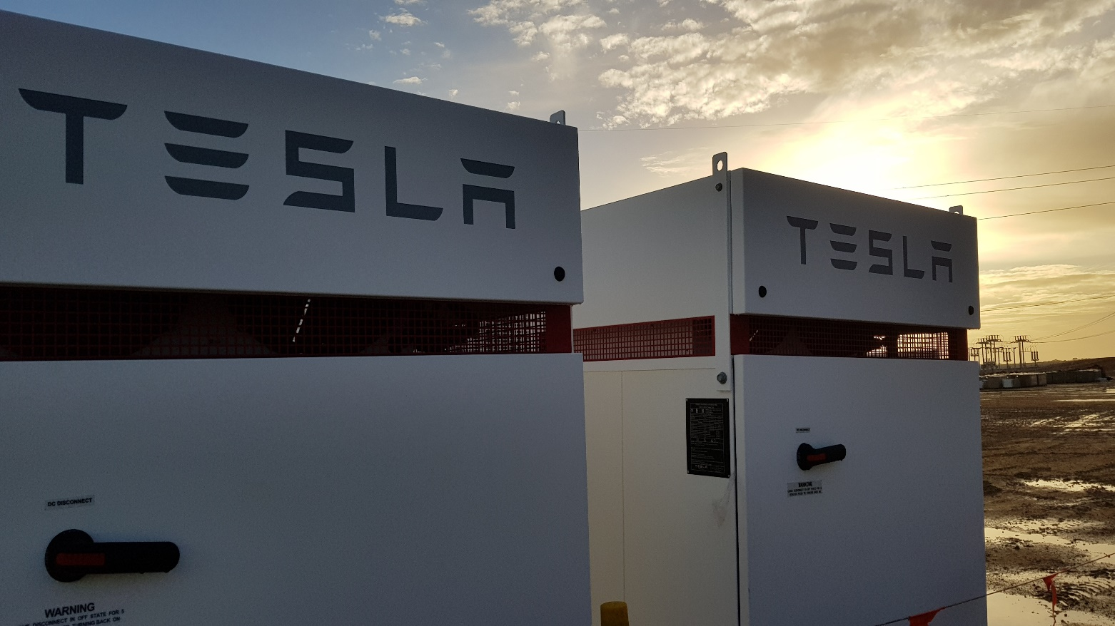

The project has great potential to inspire the development of further creative projects that will not only transform the Gannawarra Shire municipality, but also provide a high level of financial and environmental sustainability for Victoria and the local community.

Stage two of the Edify Energy/ Wirsol project has a capacity of 175-megawatts. Gannawarra Shire Council expects construction on this phase to commence in early 2019.

For more about this award-winning project, [visit the website](http://www.gannawarra.vic.gov.au/Business-and-Events/Business-Development/Large-Scale-Solar-Development) or [watch this time-lapse video](https://www.youtube.com/watch?v=_DnE3Mal5cA).