|  |  |  |
| --- | --- | --- |
| **Age-friendly Communities**  **Banyule City Council** | | |
| Banyule City Council is working towards being an age-friendly city and community. One of the recent council-led initiatives for this was an age-friendly city champion group established with Banyule residents interested in influencing and shaping the community to improve the quality of life for older people.  The environment features strongly as a base for growth of the Gannawarra brand.  With the rapid ageing of the population worldwide, it’s imperative that local government supports the active participation of older adults in their communities. The World Health Organisation’s Age-friendly Cities Global Network was established to support communities to continually assess and improve the environmental, social and economic factors that influence the health and wellbeing of older people.  To this end, Banyule Council was pleased to host the third national Age-friendly Cities Australian Forum in October 2018. More than 70 Australian and New Zealand delegates from the World Health Organisation’s Age-friendly Cities Global Network came together to learn about the latest approaches in global practices to manage the challenges associated with ageing populations. |  |  |

The main goal was creating an opportunity for local government to exchange ideas for older adults to remain connected to their neighbourhoods.

An *Age-friendly Cities* StoryPod gave delegates the opportunity to record their age-friendly stories, ideas and reflections to help inform and guide future Age-friendly Cities planning.

As part of the national forum, delegates visited the local gallery to view the ‘Engaging with Aging’ exhibition, which showcased works of art created by older residents in the community.

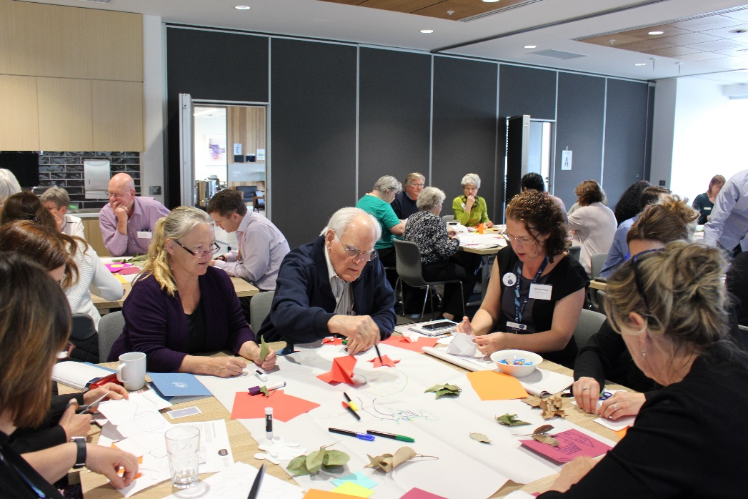

Banyule provides a range of age-friendly activities and services to assist people to live independently and be active members of the community, such as the targeted [*Age in Focus*](https://www.banyule.vic.gov.au/Services/Community-Services/Older-People/Seniors-Newsletter) newsletter and [age-friendly city champions](https://www.banyule.vic.gov.au/Services/Community-Services/Older-People/Age-friendly-City-Champions) training and media watch service, to monitor news of interest to the ageing community and gain better understanding of emerging issues.

Council also established partnerships with a number of community agencies such as neighbourhood houses, health centres, seniors' clubs and other grassroots organisations to provide opportunities for older people to stay active and social within the community.

For more about Banyule’s age-friendly initiatives, [visit the website](https://www.banyule.vic.gov.au/Services/Community-Services/Older-People/Age-friendly-City-Champions) or [watch this video](https://www.youtube.com/watch?v=o3imCgAQHok).

**Find out more about Vic Councils  
viccouncils.asn.au**

**For more information on this project:**Catherine Simcox  
Banyule City Council  
E: catherine.simcox@banyule.vic.gov.au  
P: (03) 9490 4365  
www.banyule.vic.gov.au

Banyule has established an Age-friendly Advisory Committee with membership drawn from the local community. Council has various initiatives that encourage residents to be Age-friendly City Champions and to drive participation and support for activities that make the local community more age-friendly.