|  |  |  |
| --- | --- | --- |
| **Rubbish to RoadsHume City Council**    *Photo of the road reconstruction process supplied thanks to Downer* | | |
| In an Australian-first, Hume City Council has supported a partnership between Downer and recovery and recycling companies Close the Loop and RED Group to set a new benchmark in sustainability. Soft plastics from approximately 200,000 plastic bags and packaging, along with 63,000 glass bottle equivalents will be diverted in this trial from landfill to construct a Victorian road.  Along with soft plastics and glass, toner from more than 4,500 used printer cartridges and 50 tonnes of recycled asphalt were also repurposed to create 250 tonnes of asphalt. This innovative trial presents new avenues for recycling and repurposing waste into other streams of use - and the collaborative opportunities possible with industry partnerships and the local government sector.  This partnership is a first for Australia, presenting a unique solution to waste management and sustainability amidst a nationwide recycling crisis. It demonstrates how economic, social and environmental value can be generated from waste likely to end up in landfill, stockpiled, or a pollutant in natural environments. |  |  |

This sustainable, cost-competitive road has a 65 per cent improvement in fatigue life and a superior resistance to deformation which also makes roads last longer, allowing them to better handle heavy vehicle traffic. It is an approach which has demonstrated a great step towards a circular system by all partners involved.

The State's $2.5 million Resource Recovery Market Development Fund to boost research and development in recycling and new markets for recyclable waste contributed to this initiative.

Downer received $67,000 from the new fund and Close the Loop received $40,000 for equipment to develop the plastic additive used in the asphalt mix.

**Find out more about Vic Councils  
viccouncils.asn.au**

**For more information on this project:**  
Sintiya Khananishoo  
Coordinator, Media and Advocacy  
E: SintiyaK@hume.vic.gov.au  
P: (03) 9205 2223  
www.hume.vic.gov.au

A 300-metre stretch of road in the Melbourne suburb of Craigieburn used 50 tonnes of recycled asphalt   
with an additive comprising 530,000 plastic bags, more than 12,000 recycled printer cartridges,   
and 168,000 glass bottles. This combination of materials produced 250 tonnes of asphalt.

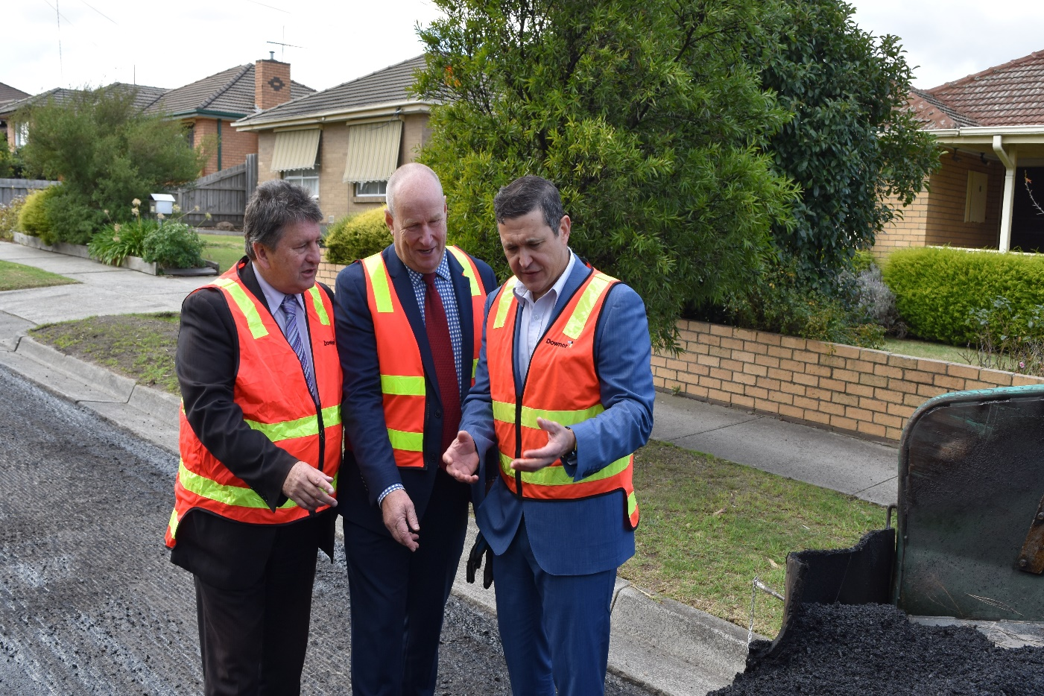

*Pictured (left to right): Hume Mayor Geoff Porter, Downer EGM Roads Infrastructure Dante Cremasco and Close the Loop Chairman Craig Devlin at the launch of the program.*

Downer estimates that up to 15 per cent of asphalt could contain soft plastics and up to 10 million tonnes of recyclable waste could be diverted from landfill every year using the new approach.