|  |  |  |
| --- | --- | --- |
| **CityLens ProjectWyndham City Council** | | |
| The CityLens project was developed by Wyndham City Council using mixed reality technology to provide a three-dimensional view of the council’s plans for an upcoming $250 million redevelopment of the Werribee City Centre. The platform was designed for optimising collaboration and engagement, allowing all stakeholders to explore urban smart cities in a novel and beneficial way.  The CityLens platform will be developed to enable the uploading and viewing of unlimited three-dimensional city models across the public sector. The holographic view allows stakeholders to see first-hand what the future holds for a city. Developers have the ability to visualise all the possibilities for a city, decision-makers can plan better and residents can share their thoughts for the future thanks to increased community engagement.  The CityLens project is a first for any government in Australia and a key component of Wyndham City’s  Smart City Strategy and Implementation Plan. Wyndham City and the Australian Government have entered a partnership to expand the project in a manner that allows other cities to utilise the same tool.  The project has been renamed CityLens to recognise the broader focus. |  |  |

Wyndham City Council was awarded grant funding from the Australian Government to use ‘Holographic Computing to Decode Our Cities’.

The CityLens platform was launched to explore holographic computing and three-dimensional city models for presentation across augmented reality environments. This collaboration will allow the platform to be designed for the varying urban environments across Australia.

The next stages of the CityLens project are now in process - the two key milestones currently being researched and implemented are the merging of city models to create a three-dimensional vision of our future cities, and pulling live Internet of Things (IoT) data through for display on the HoloLens device.

**Find out more about Vic Councils  
viccouncils.asn.au**

**For more information on this project:**  
Smart City Office  
Wyndham City Council  
E: smartcity@wyndham.vic.gov.au  
T: (03) 9742 0777

The CityLens project recognises the significant benefits of holographic computing and in particular,   
the use of immersive mediums. It will also allow data such as pedestrian and vehicle traffic, air quality,  
water usage and other sensor-derived information to be viewed on three-dimensional models.

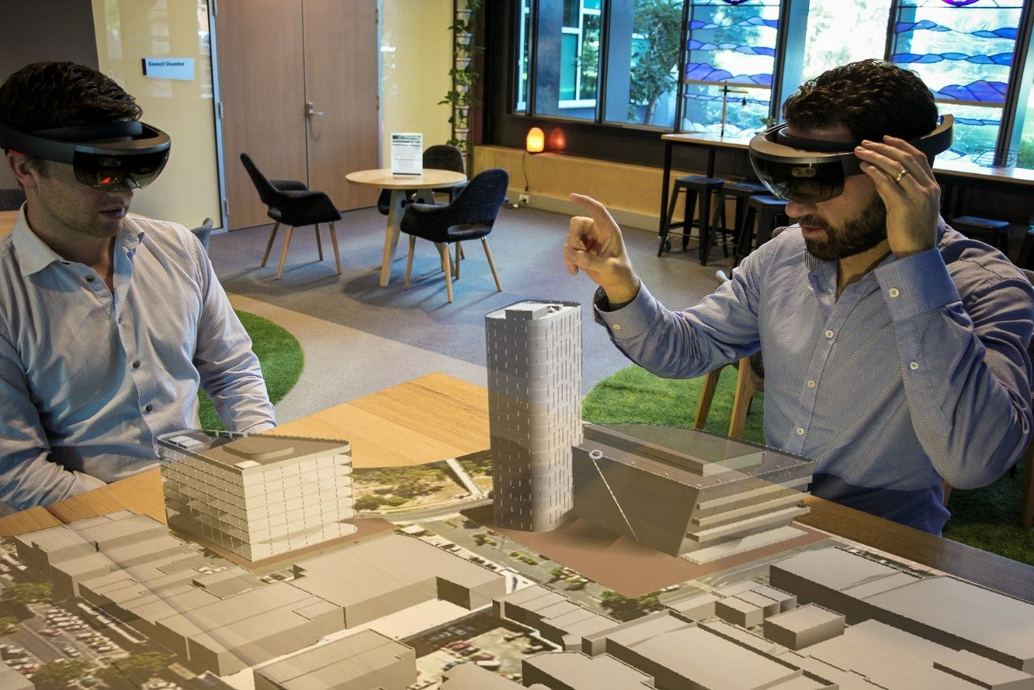

Wyndham City is working collaboratively with a number of other local councils who will share three-dimensional city models and datasets. This sharing is key towards improving visualisation outcomes, leading to greater engagement and decision-making capabilities of the CityLens platform. For more on Smart City solutions at Wyndham, visit the [CityLens](https://www.wyndham.vic.gov.au/project/citylens) website or the [Smart City Strategy](https://www.wyndham.vic.gov.au/about-council/smart-wyndham/smart-city-strategy) (2019 to 2024) and [Implementation Plan](https://www.wyndham.vic.gov.au/sites/default/files/2019-06/Wyndham%20Smart%20City%20Implementation%20Plan.pdf).