Council budgets to stimulate economy and support communities

27 June 2009

An annual analysis of local government budget data by the Municipal Association of Victoria’s (MAV) shows
council rates will increase an average of $64 or 5.16 per cent in the coming year.

Cr Bill McArthur, MAV President said councils had been responsive to the economic downturn to ensure they
maintained service levels to meet increasing community demand, and had directed spending to initiatives that
could stimulate economic development and create local jobs.

“This year balancing responsible financial management, community expectations and affordability for ratepayers
has become more complex for councils due to the financial crisis.

“Each municipality has adopted a variety of approaches to ensure spending delivers programs and services that
support communities, while also limiting cost increases for ratepayers.

“Some councils have conducted reviews to trim non-essential costs; others have reduced surpluses; and many
municipalities are proposing to increase borrowings to expand capital works programs.

“In this economic climate, increased spending on community infrastructure offers dual benefits. It helps to create
new job opportunities and addresses the $133 million annual infrastructure spending shortfall facing councils.

“Local government must concurrently plan for today’s communities and implement long-term asset management
programs that don’t unnecessarily impose massive burdens on future ratepayers.

“The cost of fixing assets becomes greater over time as they deteriorate. Funding capital works programs now
ensures councils can limit higher costs to replace ageing facilities in future years,“ he said.

Local government maintains $47.7 billion worth of local roads, drains, street lights, footpaths, childcare centres,
sporting grounds and leisure facilities relied on by communities in their daily lives and deliver more than 100
services. Rates comprise 54 per cent of total funding received by councils and represents 2.9 per cent of every
dollar raised in taxes by governments nationally.

Cr McArthur said other budget pressures on councils included higher costs to deliver the same level of services
as last year, declining grants and coordinating local response and recovery efforts following the bushfires.

“The MAV’s annual Local Government Cost Index, released last month, shows average council costs are rising
by three per cent just to stand still. While cost growth has slowed, councils are not immune to rising prices and
have limited revenue sources to absorb increases without it affecting either their rates or service levels.

“Council expenses are not reflected in the Consumer Price Index (CPI) as the delivery of council services is
affected by labour and construction costs, not price movements for common household goods and services.

“With local government so heavily reliant on State and Commonwealth funding that is linked to CPI rather than
actual costs, ratepayers were also increasingly offsetting programs such as public libraries and community care.

"It is an unsustainable model. Ratepayers are disproportionately being called upon to fund programs that should
be funded through the transfer of other Government taxes. Councils should not be left out-of-pocket," he said.

For rates data on 73 of Victoria’s 79 councils go to: www.mav.asn.au/finance/rates#resources

Contact MAV President Cr Bill McArthur
on 0437 984 793 or MAV
Communications on (03) 9667 5521
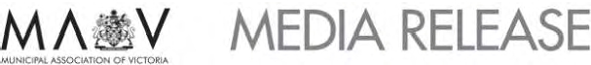

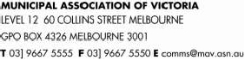

2009-10 Victorian Local Government Rates Survey

Average

Average
rates,
Change in

Total rate
revenue
Total rate
revenue
rates,
municipal
Change in
rates,
municipal
and waste
rates,
municipal

Total budgeted rate
revenue, municipal
charge and waste
as a
proportion
of total
as a
proportion
of total
and waste
management
charge
municipal
and waste
management
management
charges
09-10 per
and waste
management
charges per

management
charges for 2009-10
Budgeted total
revenue for 2009-10
revenue
09-010
revenue
08-09
09-10 per
assessment
charges per
assessment
head of
population
head of
population

ALPINE(S)
ARARAT(RC)
BALLARAT(C)
BANYULE(C)
BASS COAST(S)
BAW BAW(S)
BAYSIDE(C)
BENALLA(C)
BOROONDARA(C)
BRIMBANK(C)
$10,160,891
$10,357,066
$60,224,730
$57,481,555
$31,582,000
$28,693,671
$57,509,200
$11,513,000
$110,914,000
$91,130,595
$20,058,000
$24,832,000
$119,880,000
$98,846,000
$50,827,000
$55,464,000
$82,749,000
$19,426,000
$151,496,000
$139,161,000
51%
42%
50%
58%
62%
52%
69%
59%
73%
65%
41%
49%
48%
59%
63%
50%
68%
57%
71%
64%
$ 1,254
$ 1,490
$ 1,384
$ 1,134
$ 1,148
$ 1,380
$ 1,417
$ 1,512
$ 1,566
$ 1,266
$57
$59
$45
$59
$84
$81
$72
$56
$70
$66
$760
$902
$669
$479
$ 1,042
$714
$666
$818
$663
$499
$24
$34
$27
$28
$61
$34
$40
$32
$35
$26

BULOKE(S)
Yet to consider draft budget

CAMPASPE(S)
CARDINIA(S)
CASEY(C)
CENTRAL GOLDFIELDS(S)
COLAC-OTWAY(S)
CORANGAMITE(S)
DAREBIN(C)
EAST GIPPSLAND(S)
FRANKSTON(C)
GANNAWARRA(S)
GLEN EIRA(C)
GLENELG(S)
GOLDEN PLAINS(S)
GREATER BENDIGO(C)
GREATER DANDENONG(C)
GREATER GEELONG(C)
GREATER SHEPPARTON(C)
HEPBURN(S)
HINDMARSH(S)
$24,909,442
$40,527,988
$112,306,663
$8,281,739
$18,687,486
$14,317,759
$77,389,442
$33,374,874
$68,300,100
$7,958,933
$66,794,000
$18,882,882
$10,628,664
$62,997,817
$74,749,062
$130,481,783
$45,117,327
$ 12,177,922
$5,161,739
$55,035,000
$67,626,000
$183,719,000
$28,623,244
$36,563,000
$33,825,000
$113,795,000
$83,414,000
$121,717,000
$20,919,500
$112,127,000
$37,110,000
$27,422,844
$124,092,000
$138,674,000
$216,078,000
$100,493,000
$ 24,103,000
$13,780,631
45%
60%
61%
29%
51%
42%
68%
40%
56%
38%
60%
51%
39%
51%
54%
60%
45%
51%
37%
42%
60%
59%
32%
49%
45%
63%
51%
49%
38%
62%
49%
40%
48%
60%
60%
45%
37%
34%
$ 1,260
$ 1,395
$ 1,213
$ 1,053
$ 1,310
$ 1,514
$ 1,236
$ 1,161
$ 1,196
$ 1,184
$ 1,133
$ 1,358
$ 1,150
$ 1,243
$ 1,303
$ 1,273
$ 1,594
$ 1,188
$ 1,033
$56
$46
$60
$64
$74
$73
$61
$50
$68
$45
$62
$60
$63
$50
$56
$68
$81
$ 78
$75
$635
$588
$442
$627
$863
$833
$560
$769
$537
$704
$518
$905
$580
$614
$548
$606
$701
$ 782
$839
$34
$14
$13
$38
$45
$43
$28
$22
$34
$29
$31
$48
$30
$25
$24
$32
$37
$ 49
$66

HOBSONS BAY(C)
Did not respond to survey

HORSHAM(RC)
$14,838,397
$42,173,693
35%
47%
$ 1,285
$74
$740
$44

All data has been provided by individual councils and collated by the MAV. It is based on draft budget information for 2009-10.
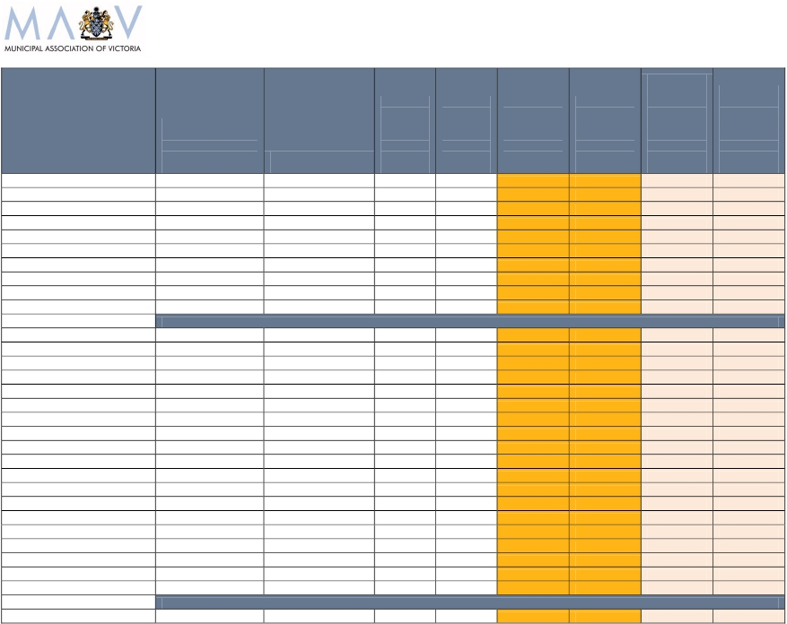

2009-10 Victorian Local Government Rates Survey

Average

Average
rates,
Change in

Total rate
revenue
Total rate
revenue
rates,
municipal
Change in
rates,
municipal
and waste
rates,
municipal

Total budgeted rate
revenue, municipal
charge and waste
as a
proportion
of total
as a
proportion
of total
and waste
management
charge
municipal
and waste
management
management
charges
09-10 per
and waste
management
charges per

management
charges for 2009-10
Budgeted total
revenue for 2009-10
revenue
09-010
revenue
08-09
09-10 per
assessment
charges per
assessment
head of
population
head of
population

HUME(C)
INDIGO(S)
KINGSTON(C)
KNOX(C)
LATROBE(C)i
LODDON(S)
MACEDON RANGES(S)
MANNINGHAM(C)
MANSFIELD(C)
MARIBYRNONG(C) ii
MAROONDAH(C)
MELBOURNE(C)
MELTON(S)
MILDURA(RC)
MITCHELL(S)
MOIRA(S)
MONASH(C)
MOONEE VALLEY(C)
MOORABOOL(S)
MORELAND(C)
MORNINGTON PENINSULA(S)
MOUNT ALEXANDER(S)
MOYNE(S)
$86,214,206
$9,809,395
$84,873,000
$72,471,821
$42,786,515
$6,868,077
$27,853,131
$62,181,588
$8,437,964
$56,653,572
$52,819,533
$ 180,397,259
$52,703,739
$42,628,000
$19,279,551
$21,460,626
$71,219,089
$66,045,254
$19,191,220
$82,460,980
$96,873,506
$12,620,850
$13,063,861
$169,993,000
$30,646,000
$137,553,000
$108,708,247
$95,833,000
$20,480,647
$60,510,353
$85,998,000
$15,874,000
$88,363,000
$86,100,000
$324,400,000
$90,063,000
$76,702,000
$36,543,000
$41,909,000
$130,363,000
$98,956,000
$30,264,000
$115,886,710
$151,228,000
$25,641,565
$38,281,000
51%
32%
62%
67%
45%
34%
46%
72%
53%
64%
61%
56%
59%
56%
53%
51%
55%
67%
63%
71%
64%
49%
34%
49%
35%
60%
65%
45%
29%
45%
66%
56%
63%
56%
54%
59%
55%
45%
48%
56%
66%
55%
70%
59%
50%
35%
$ 1,326
$ 1,229
$ 1,268
$ 1,185
$ 1,188
$906
$ 1,426
$ 1,410
$ 1,188
$ 1,698
$ 1,165
$ 2,386
$ 1,270
$ 1,556
$ 1,256
$ 1,302
$ 1,001
$ 1,351
$ 1,391
$ 1,271
$ 1,032
$ 1,193
$ 1,157
$46
$93
$77
$66
$68
$51
$80
$52
$45
$94
$55
$59
$29
$47
$72
$91
$57
$43
$39
$74
$64
$75
$45
$523
$634
$598
$472
$578
$851
$726
$533
$ 1,125
$821
$506
$ 1,932
$493
$700
$560
$715
$389
$606
$700
$547
$656
$732
$796
$22
$52
$34
$26
$31
$24
$55
$26
$55
$57
$25
$ 24
$9
$14
$32
$32
$11
$18
$6
$29
$42
$46
$34

MURRINDINDI(S)
NILLUMBIK(S)
Yet to consider draft budget
Yet to consider draft budget

NORTHERN GRAMPIANS(S)
PORT PHILLIP(C)
PYRENEES(S)
QUEENSCLIFFE(B)
SOUTH GIPPSLAND(S)
SOUTHERN GRAMPIANS(S)
STONNINGTON(C)
$10,611,550
$78,293,000
$5,874,351
$4,821,855
$25,448,433
$12,042,178
$67,079,874
$21,815,765
$140,488,000
$15,738,000
$7,627,752
$42,152,056
$30,107,830
$113,516,000
49%
56%
37%
63%
60%
40%
59%
41%
57%
31%
60%
59%
37%
56%
$ 1,163
$ 1,255
$ 1,022
$ 1,614
$ 1,368
$ 1,136
$ 1,260
$72
$36
$50
$85
$55
$48
$56
$847
$833
$890
$ 1,479
$920
$683
$679
$54
$29
$52
$91
$38
$30
$29

All data has been provided by individual councils and collated by the MAV. It is based on draft budget information for 2009-10.
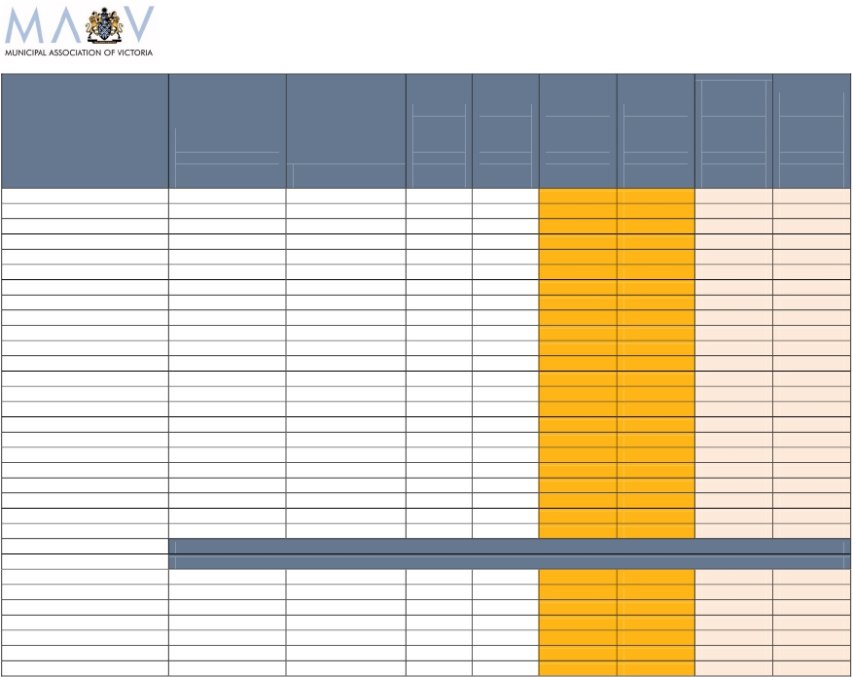

2009-10 Victorian Local Government Rates Survey

i
ii

Note excludes payments in lieu of rates made by electricity generators
Note the high incidence of industrial and commercial assessments within the municipality means average residential rates per assessment of approx. $1,369 is more representative

of the rates paid by households in Maribyrnong.

All data has been provided by individual councils and collated by the MAV. It is based on draft budget information for 2009-10.

 | Total budgeted rate  revenue, municipal  charge and waste  management  charges for 2009-10 | Budgeted total  revenue for 2009-10 | Total rate  revenue  as a  proportion  of total  revenue  09-010 | Total rate  revenue  as a  proportion  of total  revenue  08-09 | Average  rates,  municipal  and waste  management  charge  09-10 per  assessment | Change in  rates,  municipal  and waste  management  charges per  assessment | Average  rates,  municipal  and waste  management  charges  09-10 per  head of  population | Change in  rates,  municipal  and waste  management  charges per  head of  population
STRATHBOGIE(S) | Yet to consider draft budget
SURF COAST(S) | $30,013,425 | $55,507,000 | 54% | 50% | $ 1,614 | $81 | $ 1,186 | $44
SWAN HILL(RC) | Yet to consider draft budget
TOWONG(S) | $4,979,372 | $11,897,000 | 42% | 42% | $ 1,348 | $45 | $798 | $20
WANGARATTA(RC) | $18,840,464 | $44,372,530 | 42% | 40% | $ 1,311 | $45 | $680 | $30
WARRNAMBOOL(C) | $22,005,389 | $52,348,000 | 42% | 42% | $ 1,438 | $70 | $663 | $30
WELLINGTON(S) | $34,556,722 | $65,261,000 | 53% | 52% | $ 1,055 | $54 | $829 | $11
WEST WIMMERA(S) | $4,166,736 | $16,731,960 | 25% | 28% | $910 | $27 | $896 | $16
WHITEHORSE(C) | $67,524,903 | $119,200,000 | 57% | 53% | $ 1,025 | $53 | $441 | $23
WHITTLESEA(C) | $ 76,900,150 | $ 125,439,000 | 61% | 60% | $ 1,300 | $ 51 | $ 496 | $ 15
WODONGA(RC) | $26,323,454 | $48,997,797 | 43% | 40% | $ 1,608 | $81 | $743 | $44
WYNDHAM(C) | $90,157,581 | $156,869,000 | 57% | 51% | $ 1,416 | $139 | $602 | $69
YARRA (C) | $67,837,710 | $118,800,000 | 57% | 57% | $ 1,565 | $47 | $898 | $34
YARRA RANGES(S) | $83,956,281 | $131,043,000 | 64% | 63% | $ 1,373 | $76 | $572 | $36
YARRIAMBIACK(S) | $7,627,090 | $16,125,000 | 47% | 46% | $ 1,141 | $79 | $ 1,014 | $76
Total | $ 3,245,423,982 | $5,738,363,124 | 57% | 55% | $ 1,310 | $ 64 | $ 623 | $ 29
Change in local government revenue | 3.84%
Change in rates, municipal charges and waste charges per assessment | 5.12%
Change in rates, municipal charges and waste charges per head | 4.94%
Average change in rates, municipal charge and waste charges per assessment | $64
Average change in rates, municipal charge and waste charges per head | $29
Average rates, municipal charge and waste charges per assessment | $1,310
Average rates, municipal charge and waste charges per head | $623

HOW COUNCIL RATES DATA IS PRESENTED

Rates per assessment

The MAV has used average rates, municipal charges and garbage charges per
assessment to measure rate movements in 2005, 2006, 2007, 2008 and 2009.

Average rates per assessment are an estimate of the average rate bill received by
households.

Demographic characteristics and the economic and industry profile of the community
affect the quantum average rates per assessment.

For example, councils with high levels of commercial and industrial businesses tend to
have higher rates per assessment than other councils do, irrespective of the residential
rates. For these councils, the residential rates per assessment are likely to be lower
than the municipal wide average.

Likewise, councils with little or no commercial and industrial activities and with large
households will also tend to have higher rates per assessment.

In addition, a single farm enterprise may include several assessments, which will skew
the data.

Rates per head of population

The MAV has adopted average rates, municipal charges and garbage charges per
head of population to measure rates for 2006, 2007, 2008 and 2009.

Average rates per head are a good measure of the comparative tax burden placed
on the communities with other levels of government. Many of the taxes levied by the
Commonwealth and State Government are compared on a per head basis; this
measure enables a valid comparison with these figures.

It is also a useful measure in gaining a clearer picture of the rates structures of
councils that have little or no industrial activities and large households.

Rates per head is an increasingly useful measure of local government rates as the
services provided by councils expand from property-based to human based services.

Further Information:
Council rates data for 2003, 2004, 2005, 2006, 2007, 2008 and 2009 is available on
the MAV website at: www.mav.asn.au/finance/rates#resources

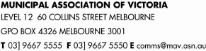

LOCAL GOVERNMENT COST PRESSURES

A range of cost pressures influence the decisions each council makes about its annual budget
and the rates it needs to collect.

1. GLOBAL FINANCIAL CRISIS
During an economic downturn, local government plays a key role in supporting its communities. With growing
unemployment, councils are likely to experience an increased demand for social, recreation and community
health services and programs. Increasing spending by councils on local community infrastructure projects
also helps to stimulate economic development and create local job opportunities.

2. COST SHIFTING
Cost shifting is when Commonwealth and State programs transfer responsibilities to local government with
insufficient funding or grants which don’t keep pace with actual service delivery costs. Intergovernmental
agreements were signed with the Commonwealth (2006) and Victorian Government (2008) to establish an
agreed framework for allocating responsibilities and appropriate funding to local government. While these
agreements cover future transfers of responsibility, past cost shifting pressures continue to confront councils.
Rates revenue is commonly used to redress funding shortfalls to meet increasing service demands, rising
costs and community expectations. This occurs most notably in home and community care, kindergarten
infrastructure, public libraries, school crossings and immunisations.

2. INFRASTRUCTURE RENEWAL GAP
Victorian councils are responsible for community infrastructure worth $47.7 billion. Funding to adequately
maintain and renew ageing assets was calculated in 2006 by the MAV as facing an annual shortfall of $280
million (equivalent to an annual average 12 per cent rate increase). To address the infrastructure renewal
gap and prevent it from growing, councils have significantly increased capital works programs. However, a
limited capacity to raise revenue has seen a range of other options adopted such as rate increases and
reduced service levels. In 2009, the annual infrastructure spending shortfall was reduced to $133 million due
to improved data collection; increased funding (through rates and borrowings); and asset rationalisation.

3. LOCAL GOVERNMENT COST INDEX
The MAV Local Government Cost Index calculates any change in costs to deliver goods and services
provided by Victorian councils. To deliver the same level and range of services as 2008, it will cost local
government three per cent more in 2009. This is largely due to a ‘basket’ of council services being affected
by the growth in construction, material and wage costs, rather than changes in common household goods
and services as measured by CPI. The majority of council expenditure is staff and contractors to deliver
human-based services; and staff and materials to construct, maintain and upgrade community assets.

4. DECLINING GOVERNMENT GRANTS
Local government nationally collects only 2.9 per cent (or $10.1 billion) of the $348 billion in total taxes raised
by the three levels of government. Core financial assistance through Commonwealth tax distribution to local
government has declined from 1.2 per cent in 1993-94 to 0.97 per cent in 1996-97 and 0.79 per cent in
2008-09. Local government requires a fairer funding formula and indexation that takes account of actual
local government cost movements over time.

5. CAPPED USER FEES AND CHARGES
Capping of many user fees and charges by the Victorian Government leaves councils unable to recover the
true cost of delivering services such as planning and building, heritage protection, home care and public
libraries. Instead rate revenue is used to cross-subsidise the delivery of these services.

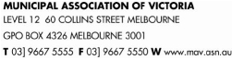

FUNDING OF LOCAL GOVERNMENT

Australian Taxation System

The Australian Constitution unequally divides taxation powers and expenditure responsibility
between the Commonwealth and state governments
This division has resulted in the Commonwealth collecting around 68 per cent and the states
around 29 per cent of the total taxes collected in Australia
Local government collects three per cent of the total taxes collected by all governments
To equalise taxation revenues and spending responsibilities, the Commonwealth makes a series
of grants to the states and local government.

Local Government Income Sources

There are several sources of funding for local government in Victoria:

Rates on property

Fees, fines and charges (eg. swimming pool and gymnasium entry fees, waste depot fees,
planning permit fees, parking fees and fines)

Specific purpose grants from State and Commonwealth Governments, for funding specific
projects or programs

General purpose grants from the Commonwealth Government not tied to a specific purpose.

Other sources: borrowings (eg. to pay for large infrastructure projects), asset sales, donations,
contributions, reimbursements and interest earned.

Local Government Funding Sources

The total funding for local government in Victoria in 2007-08 from all sources was $5.5 billion including:

$2.98 billion or 54.2% in rates
$975 million or 17.7% in fees, fines and charges
$705 million or 12.8% in specific purpose grants
$415 million or 7.5% in untied revenue from general purpose grants
$432 million or 7.8% in other sources

Local government collects approximately three cents of every dollar raised in Australian taxes. The
Commonwealth receives approximately 68% of total taxation revenue and the States receive 29%.

VICTORIAN LOCAL GOVERNMENT SNAPSHOT

Local Government Facts

Victoria has 79 municipalities:

o
o
o
o
31 metropolitan (including eight Interface councils)
48 rural and regional (including 10 regional cities)
Populations range from 3,200 to more than 238,000
Each varies in size, rate base, needs, infrastructure and resources

Each municipality manages significantly different budgets:

o
o
Rural council budgets average $39 million (smallest is approx $7 million)
Metropolitan council budgets average $113 million (largest is approx $370 million)

Governed by 631 democratically elected councillors
Employs 39 940 people
Annual revenue of $5.5 billion
Responsible for $47.7 billion in assets

Service Delivery Statistics

Local government in Victoria:

Services 128,582 kilometres of roads (approximately 85% of Victoria’s total road network)
Provides 580,000 maternal and child health consultations a year
Delivers 306,600 immunisations to preschool and secondary school children a year
Delivers 3.7 million meals a year to home care recipients
Provides 4 million hours of home assistance, property maintenance, personal and respite care a year
Spends $40 million on public street lighting each year
Loans 45.5 million books from 317 public libraries to 2.5 million registered library users a year
Provides internet access for more than 2.5 million bookings a year
Processes more than 52,000 planning applications a year
Maintains more than 1000 grassed sports surfaces
Collects 1 million tonnes of kerbside garbage a year
Collects 560,000 tonnes of recyclable materials a year
Collects 246,000 tonnes of organic waste a year

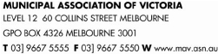

COUNCIL RESPONSIBILITIES

Role of Local Government

Local government provides for the peace, order and good government of its municipal area, delivers
services and facilities for the community and manages the resources of the district.

Local government must operate in accordance with the Local Government Act 1989 and has responsibility for
implementing many diverse programs, policies and regulations set by the State and Federal Government.

As councils have to respond to local community needs they also have powers to set their own regulations
and by-laws, and to provide a range of discretionary services.

Local laws developed by councils deal with important community safety, peace and order issues such as
public health, management of council property, environment and amenity. Local laws often apply to noise,
fire hazards, abandoned vehicles, parking permits, disabled parking, furniture on footpaths, graffiti, burning
off, animals in public spaces and nuisance pets.

Services and Infrastructure

Each Victorian municipality is different – its community may be young or old, established or still developing,
rural or urban, and its population may vary from fewer than 3,200 people to more than 238,000.

Each council collects rates from property owners in its municipality to help fund its local community
infrastructure and service obligations.

Victorian councils are responsible for $47.7 billion of infrastructure including roads, bridges, town
halls, recreation and leisure facilities, drains, libraries and parks. They also provide over 100 services
for local communities from the cradle to the grave. Every time a person leaves their house they are
using services provided by local councils.

Road assets:

Community assets:

local roads, drains, bridges, foot and bike paths, public street lighting, litter bins,
school crossings, bus shelters, parking spaces.

libraries, internet services, sporting facilities, community halls, parks and gardens,

swimming pools, playgrounds, animal shelters, public toilets, public art, cemeteries.

Community services: community banking, public tips, removal of dumped rubbish, youth and family
counselling, baby capsule hire, childcare programs, playgroup, preschools and
kindergartens, school holiday programs, immunisations, food safety inspections,
planning advice and approvals, street cleaning.

In-home services:

Family day care, parenting and baby health advice by maternal and child health nurses,
multilingual telephone services, recycling and hard waste collections, home
maintenance, meals on wheels, gardening services and respite care.

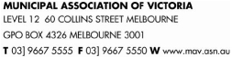

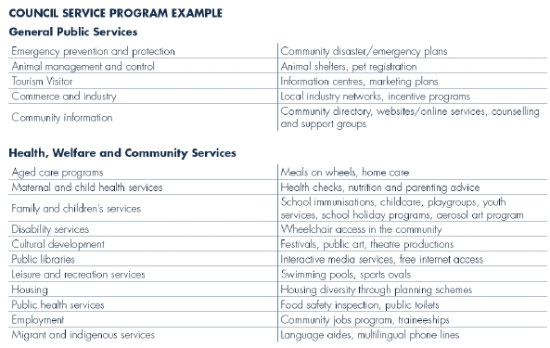

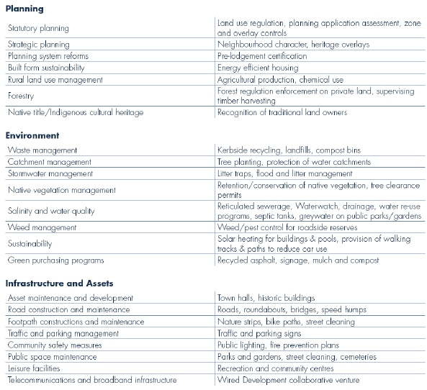

SETTING A COUNCIL BUDGET

Council Plan

Victoria’s 79 councils operate as separate entities with different local issues, costs and service provision needs.

All councils identify the needs and issues to be dealt with in their municipality in their Council Plan.

This Plan is a statutory requirement which describes the strategic objectives and strategies to be
implemented by a council for the coming year, as well as the following four years.

Each council issues a public notice seeking community input to its draft plan for 14 days, before the plan is
finalised and adopted by council for submission to the Minister. It must be completed by 30 June each year.

Strategic Resources Plan

A Council Plan must include a Strategic Resources Plan, which sets out the financial and human resources
required to achieve its objectives over five financial years.

The Strategic Resources Plan is updated annually.

Council Budget

Each council budget is different to reflect local community needs and priorities. However, there is a
common legislated framework for setting a budget that each council must follow.

The budget process involves a council setting its priorities, identifying measures and allocating funds that
will show how the key strategic objectives outlined in its Council Plan are to be achieved in the coming year.

Through the budget process a council also specifies the annual maintenance, upgrade and renewal needs
of its assets and any new or replacement infrastructure; as well as the community services and facilities it
will provide in the next financial year, and how much these will cost.

A council budget also estimates the revenue to be collected from other sources such as State and Federal
Government funding and from loans. By using these estimates a council can determine the amount it needs
to collect in rates to meet its financial responsibilities for the coming year.

This information is adopted as a draft budget, which is advertised and open to public comment for a
minimum of 14 days.

All councils are required to submit their budget to the Minister before 31 August each year.

Local government has an open and transparent budget-setting process that seeks community
discussion and input to the development of council spending initiatives and priorities for the
coming year.

LOCAL GOVERNMENT RATING PRINCIPLES

Property Taxation System

Property taxes (rates) are a wealth tax charged by local government municipalities
Local councils can also apply a municipal charge (of not more than 20% of their total rate revenue); a waste
management charge; and other special rates and charges as deemed appropriate by councils
Exemptions from rates apply to crown land, charitable land, land used for religious purposes, and land
used exclusively for mining and forestry
Rate revenue comprises around 54.2 per cent of Victorian councils’ total revenue
Council rates do not represent a direct user pays system because local government provides services
and infrastructure for public benefit .

PRINCIPLE: Those with a higher valued property relative to others within a municipality contribute
a larger amount in rates

Rating Equity

Rates are distributed between ratepayers based on the relative value of properties within a municipality
Properties are revalued every two years to maintain a fair distribution of the rates burden between
property owners within a municipality
There is a direct relationship between property holdings and disadvantage – less wealthy people tend to
own lower valued housing stock
Property owners with higher valued assets generally have a greater capacity to pay
Property taxes do not take into account individual debt levels or income received by owners – there are other
taxes applying to income and expenditure which should be considered when assessing tax equity.

PRINCIPLE: There is no connection between the amount of rates paid and the level of council
services received by individuals.

Municipal Charges

A municipal charge may be used by a council to collect a portion of revenue not linked to property value
but paid equally by all ratepayers
Farm owners with multiple property assessments for rates only attract a single municipal charge.
User fees imposed by councils (such as municipal and waste management charges) help to redistribute the
burden of rates as they are paid equally by all ratepayers and reduce the total property rates required by a
council to fund its annual budget.

PRINCIPLE: The use of a municipal charge reduces the amount that needs to be collected in the
form of rates attached to the value of a property.

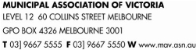

COUNCIL RATES EXPLAINED

Australia’s tax system uses the payment of taxes to fund a variety of programs, services and
infrastructure by all levels of government for the public benefit of all.

Property Tax

Council rates are a property tax. Councils use property values as the basis for calculating how much each
property owner pays in rates.

In Victoria, council rates can comprise up to three components:
municipal charges (of not more than 20 per cent of a council’s total rates revenue)
waste management (garbage) charges
rate in the dollar.

Exemptions from rates apply to crown land, charitable land, land used for religious purposes, and land used
exclusively for mining or forestry.

There is no connection between the amount of rates paid by a property and the level of council services
received.

PRINCIPLE: Those with a higher valued property relative to others within a municipality will
contribute more in rates that those with a lower valued property

Rate Process

Once a council has identified the total amount it needs to collect in rates (as determined by its prescribed
budget process), rates and charges can be calculated. A council begins its rate process each year by
determining any municipal and waste management charges that may be needed to recover part of the
administrative cost and the cost of providing waste collection and disposal services respectively.

Once these discretionary charges have been accounted for, a council establishes its rate in the dollar by
dividing the balance of required budget revenue by the total value of all rateable properties in the municipality.

The rate in the dollar is then multiplied by the value of a property (using one of three valuation bases) to
establish the amount to be paid by each property owner. This amount is known as the general rates.
General rates are added to any municipal and waste management charges set by a council to determine
the total rates payable on a property.

Example: Calculating General Rates

The total value of rateable properties within a municipality is $10,000,000,000 and council needs to collect

$40,000,000 in rates. The rate in the dollar is 0.004 (40,000,000
10,000,000,000). The rates payable on a

property valued at $320,000 would be $1280 ($320,000 x 0.004).

An increase in property values does not cause a rate rise. Council budgets are pre-determined to
meet expenditure requirements, and include any potential rate rise. Property valuations are used
to distribute how much each ratepayer will pay, according to the value of their property compared
to other properties within the municipality.

COUNCIL RATING BASES

Each Victorian council chooses one of three valuation bases for their municipality - Capital Improved
Value (CIV), Site Value (SV), or Net Annual Value (NAV).

The common process for calculating each of the three valuation bases is as follows:

Every two years council valuers have a statutory requirement to conduct a review of property
values based on market movements and recent sales trends
The last revaluation is based on levels as at 1 January 2008
Council valuers undertake a physical inspection of a sample of properties
The total value of property in a municipality is used as the base against which that council strikes
its rate in the dollar
The rate in the dollar is multiplied by the CIV, SV or NAV value of the property to determine the
general rates due on each property
The Valuer General is responsible for reviewing the total valuation of each municipality for
accuracy before he certifies that the valuations are true and correct.

Capital Improved Value

CIV refers to the total market value of the land plus the improved value of the property
including the house, other buildings and landscaping

Site Value

SV refers to the unimproved market value of the land

Net Annual Value

NAV is the annual rental a property would render, less the landlord’s outgoings (such as
insurance, land tax and maintenance costs) or 5% of the CIV for residential properties and farms
The value is higher for commercial/industrial and investment properties.

